**Year 11 Human Biological Science**

**Circulatory and Respiratory System**

Name: ____________________________________________ /45

Multiple Choice Answer Sheet

|  |  |
| --- | --- |
| Question | Answer |
| 1 | A B C D |
| 2 | A B C D |
| 3 | A B C D |
| 4 | A B C D |
| 5 | A B C D |
| 6 | A B C D |
| 7 | A B C D |
| 8 | A B C D |
| 9 | A B C D |
| 10 | A B C D |
| 11 | A B C D |
| 12 | A B C D |
| 13 | A B C D |
| 14 | A B C D |
| 15 | A B C D |

**PART A: Multiple Choice (15 marks)**

1. Which of the following best described blood carried in the pulmonary vein.

a) It is deoxygenated and will enter the left atrium

b) It is deoxygenated and will enter the heart after passing the semi lunar valve

c) It is oxygenated and will enter the left atrium

d) It is oxygenated and will enter the heart after passing the semi lunar valve

2. What is the role of the chordinae tendonae?

a) They act as a portion of the skeleton of the heart, strengthening heart walls.

b) They keep the semilunar valves in position.

c) They keep the atrio-ventricular valves from opening in the wrong direction.

d) They contract to move blood through the heart.

3. Capillaries :

a) are one cell thick and allow nutrients to move into the cells.

b) are one cell thick which allows carbon dioxide to move from the plasma into muscle cells.

c) contain smooth muscle and can undergo vasoconstriction.

d) carry deoxygenated blood to the body tissues.

4. The majority of the oxygen in human blood is:

a) dissolved in the plasma.

b) chemically converted to water.

c) combined with haemoglobin.

d) combined with carbon dioxide to form bicarbonate ions.

5. Which of the following is correct about a platelets?

a) They help to carry oxygen and have the scientific name Thrombocytes.

b) They fight disease and have the A antigen and anti B and anti AB antibodies

c) They help to clot blood at a wound site and have the scientific name Thrombocytes.

d) They help to clot blood at a wound site and have the scientific name erythrocytes.

6. Complete the sentence with the correct terms:

Blood from the arms returns to the heart via the _____1_____ and enters the ____2____.

|  |  |  |
| --- | --- | --- |
|  | 1 | 2 |
| a) | Vena cava | Right atrium |
| b) | Vena cava | Left atrium |
| c) | Pulmonary vein | Right atrium |
| d) | Femoral vein | Left atrium |

7.

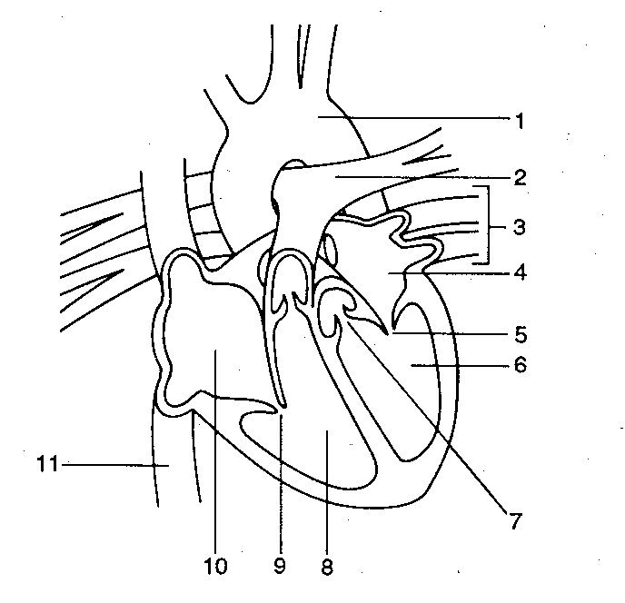

Using the diagram above, which of the following label the parts of the heart correctly:

|  |  |  |  |
| --- | --- | --- | --- |
| A | 7 = semilunar valve | 9 = atrioventricular valve | 3 = pulmonary artery |
| B | 8 = left ventricle | 1 = aorta | 5 = semilunar valve |
| C | 4 = left atria | 3 = pulmonary vein | 11 = superior vena cava |
| D | 11 = inferior vena cava | 2 = pulmonary artery | 1 = aorta |

8. The major driving force that moves blood in the veins is

a) active transport.

b) passive transport.

c) the closing of one-way valves.

d) skeletal muscle contractions.

9. Cardiac output can be reduced by

a) increasing heart rate.

b) decreasing stoke volume.

c) increasing the strength of ventricular contraction.

d) decreasing the concentration of oxygen in the blood.

10. Which of the following is INCORRECT about blood clotting?

a) Platelets stick to any damaged surfaces of blood vessels, attracting more platelets

b) During clot retraction plasma is squeezed out of the clot

c) Fibrin are threads of insoluble proteins

d) Stuck platelets release vasoconstrictors

11. During the last stage of the cardiac cycle, which of the following events is occurring?

a) Atria relax while the ventricles contract; atrioventricular valves are closed while the semilunar valves are open.

b) Atria contract while the ventricles relax; atrioventricular valves are open while the semilunar valves are closed.

c) Atria and ventricles are relaxed; atrioventricular valves are open while the semilunar valves are closed.

d) Blood moves from the right ventricle into the aorta while blood moves from the left ventricle to the pulmonary artery.

12. Haemoglobin is:

a) found in leucocytes and helps to figth disease.

b) found in erythrocytes and helps to fight diseasse.

c) found in erythrocytes and helps to caryy oxyen.

d) found only in lymphatic tissue.

The next THREE questions refer to the following diagram:

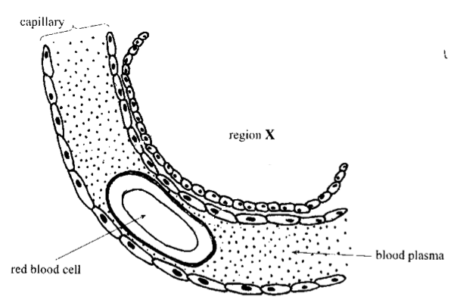

13. The region labelled X represents

a) pulmonary artery.

b) air in alveolus.

c) villus.

d) lung cappilary.

14. The feature labelled red blood cell:

a) is called a Erythrocyte and carries the majority of the Carbondioxide in the blood in the form of carbaminohaemoglobin

b) is called a Erythrocyte and carries the majority of the Oxygen in the blood in the form of oxyhaemoglobin

c) is called a Thrombocyte and carries the majority of the Carbondioxide in the blood in the form of carbaminohaemoglobin

d) is called a Thrombocyte and carries the majority of the Oxygen in the blood in the form of oxyhaemoglobin

15. The concentration of carbon dioxide gas in the capillary is:

a) high and will move into region X.

b) low and will move into the blood plasma.

c) high and will move onto the red blood cell.

d) low and will move from the red blood cell to region X.

**PART B: Short Answers (30 marks)**

1a. complete the table below.

|  |  |  |  |  |
| --- | --- | --- | --- | --- |
|  | Name of type of vessel | Direction that blood flows while moving through it | Blood pressure | Does it have valves? |
|  |  |  |  |  |
|  |  |  |  |  |

(8 marks)

1b. Which type of vessel has not been shown in the table above? (1 mark)

_______________________________________________________________________________________

1c. Describe the pressure of blood seen in the vessels listed in answer 1b. (1 mark)

_______________________________________________________________________________________

2. The diagram below shows a capillary and the surrounding cells it supplies

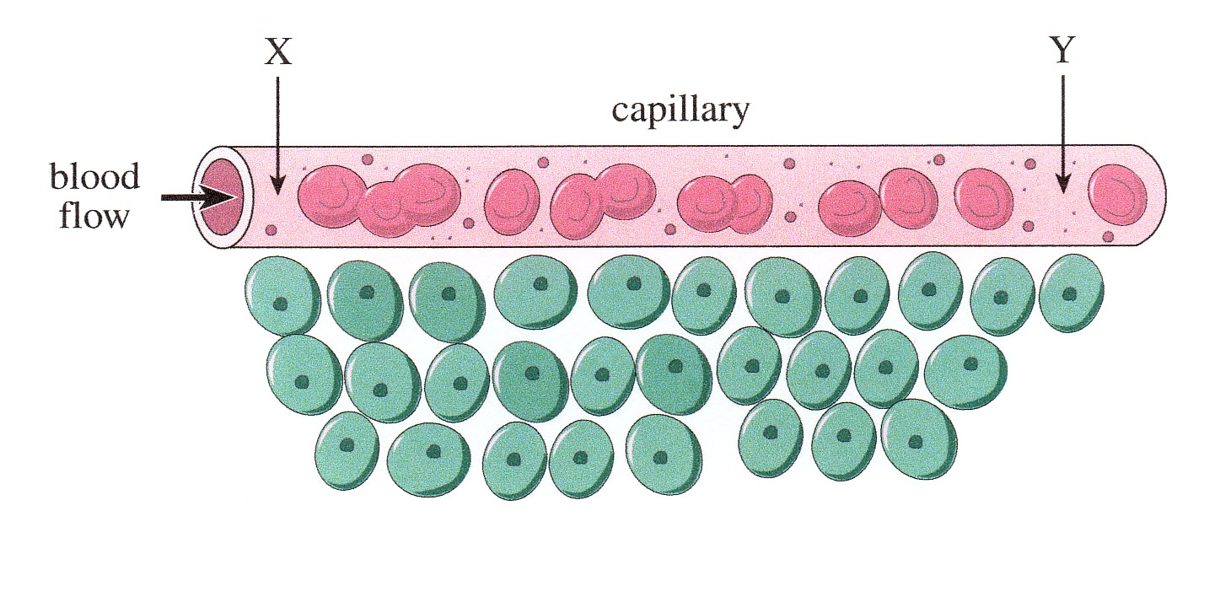

CIRCLE the CORRECT term in each of the following statements.

As blood flows through the capillary from Point X to Point Y: (6 marks)

1. the amount of glucose in the blood INCREASES / DECREASES.
2. the amount of oxygen in the blood INCREASES / DECREASES.
3. the amount of carbon dioxide in the blood INCREASES / DECREASES.
4. the amount of oxyhaemoglobin in the blood INCREASES / DECREASES.
5. the amount of carbaminohaemoglobin in the blood INCREASES / DECREASES.

vi) the pressure in the vessel INCREASES / DECREASES.

3. During a heart dissection, you notice that ‘one side’ of the heart is much thicker that the other side (see photo below). Your group members say this is because the thick side pumps more blood as the heart is a double pump.

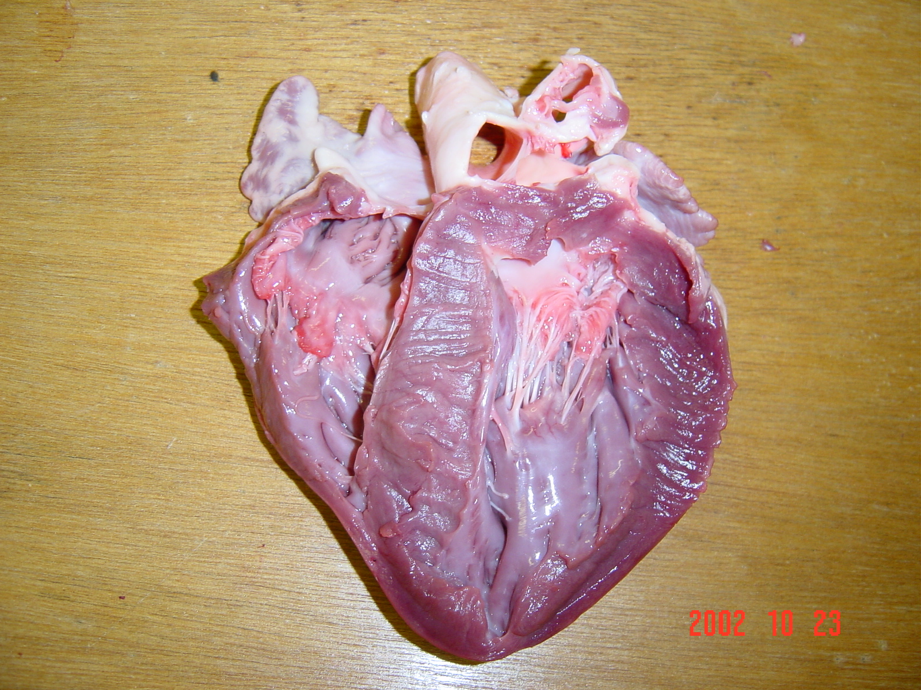

Thicker

Side.

a) What is the ‘thick part’ of the heart structure that is being examined? (1 mark)

_______________________________________________________________________________________

b) Are your fellow group members correct for stating that ‘*this side is thicker as it pumps more blood’*?

Explain. (2 marks)

_______________________________________________________________________________________

_______________________________________________________________________________________

_______________________________________________________________________________________

4. Use the diagram below to answer the questions that follow.

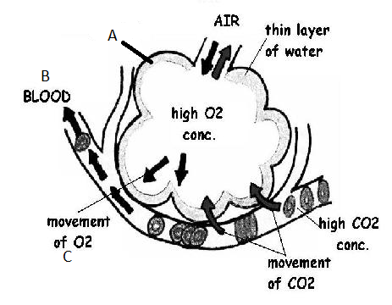

**D**

1. What is the name of structure A? (1 marks)

_______________________________________________________________________________________

_______________________________________________________________________________________ State two characteristics of structure A that help with the diffusion of gasses into and out of the blood.

(2 marks)

_______________________________________________________________________________________

_______________________________________________________________________________________

_______________________________________________________________________________________

1. Where is the blood at point B going?

(1 mark)

_________________________________________________________________________________________________________________________________________________________________

1. At point C on the diagram what do we call the type of transport that brings oxygen into the blood?

(1 mark)

_________________________________________________________________________________

1. Why would oxygen levels be low at point D?

(2 marks)

_______________________________________________________________________________________

_______________________________________________________________________________________

_______________________________________________________________________________________

_______________________________________________________________________________________

_______________________________________________________________________________________

_______________________________________________________________________________________

5. Describe what happens to cause air to move into the lungs during inhalation.

(4 marks)

_______________________________________________________________________________________

_______________________________________________________________________________________

_______________________________________________________________________________________

_______________________________________________________________________________________

_______________________________________________________________________________________

_______________________________________________________________________________________

_______________________________________________________________________________________

_______________________________________________________________________________________

_______________________________________________________________________________________

_______________________________________________________________________________________

_______________________________________________________________________________________

_______________________________________________________________________________________